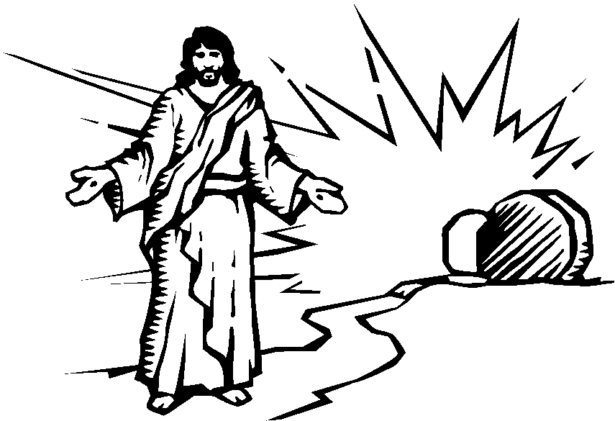

Christ has been raised from the dead.
1 Corinthians 15:20 _{NLT}

